Vihari Gardens -2

Please attach Site photos from google map
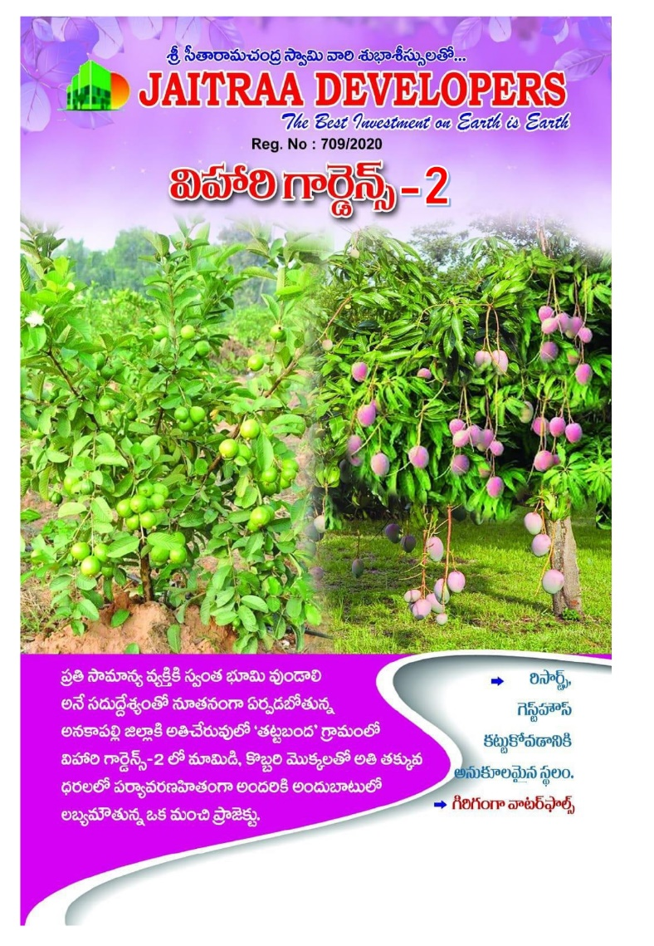
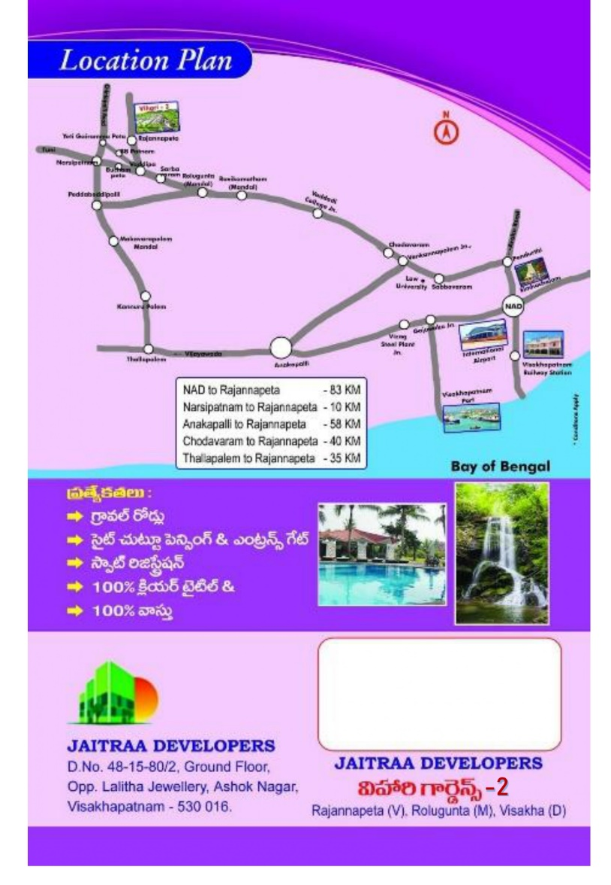

Attach LAYOUT COPY here
Layout copy should be displayed and downloadable

Project Amenities & Developments
- Mahagani, teak and coconut Plantation project situated at Rajannapaeta Village near Nrasipatnam, Rolugunta mandal in Anakapalli District.
- Plots sizes varying from 100 Sq yards to 1020 and all plots are as per Vastu
- Plot sizes Starts from 10.5 Cents You Will be Getting Passbook and Patta
- Best plot sizes suitable for resorts construction
- Free Maintenance of farm lands
- All Gravel roads
- 24 hours security
- Entrance Arch
- Fencing to the entire layout
- Children play area
- Solar Electricity and Water Supply

Benefits of Investing
- Project situated about 10 kms from Narsipatnam Bus stand and 25 km to Lambasingh.
- Situated very near to 100 feet road i.e., Tuni-Raipur High way
- Project facing 40 feet R&B road
- Project is situated nearer to Lambasingh tourism area and suitable for Resorts construction
- Best project with very reasonable prices which gives good benefits over a period
- Investment with very good scope of returns.
- A good investment option for guaranteed future returns.

Site Address & Location
Vihari Gardends-2, Rajannapeta Village, Near Narsipatnam, Rolugunta (Mandal), Anakapalle(Dist),
Andhra Pradesh - 531114
- +91-99888 38367, 84999 69716
- jaitradevelopers@gmail.com

Google Site location: https://maps.app.goo.gl/LPw9f8FExLaHUZSY7

